Step by step instructions on how to use the ActionTrak Connector app into the QB desktop .

**First:**

Open the “Integrated Applications" in the QB desktop; Edit>Preferences>Integrated Applications, and click the Company Preferences tab.

**Second:**

Now, in the Company Preferences tab, Add this name “ActionTrak Connector” into the application name list column, and put “check” into its corresponding box in the “Allow Access” column and click “OK” (Note: Make sure to clear the “Don’t allow any applications to access this company file” checkbox).

**Third:**

Now, we need to create a taxable item and non-taxable item. Below are the details of each item.

**For taxable**

Type: Other Charge

Name: Item Tax

Tax Code: Tax

Desc: Taxable

**For non-taxable**

Type: Other Charge

Name: Item Non-Tax

Tax Code: Non

Desc: Non-Taxable

**Fourth:**

Note that the QB desktop won’t allow any applications whose certificate is invalid or if the publisher is unknown. Since the certificate that I used in this application is only valid in my local machine, we need to install the certificate in your own local machine.

* so to do this you need to run “mmc” on the startup menu and console window will open.

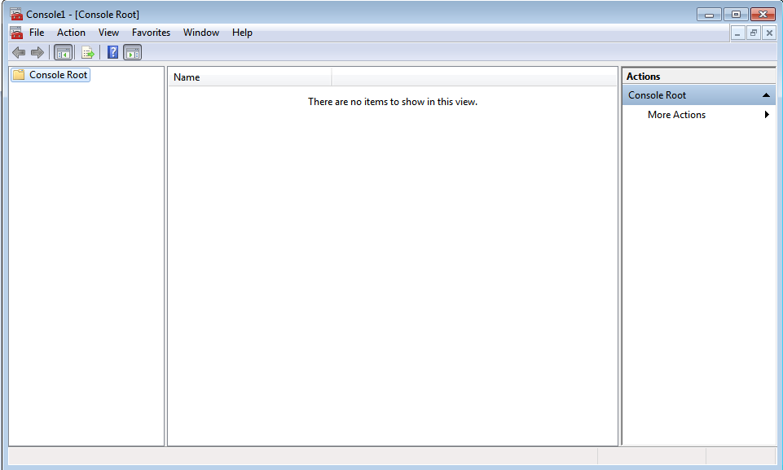

* Click “File” and open “Add/Remove Snap ins”.

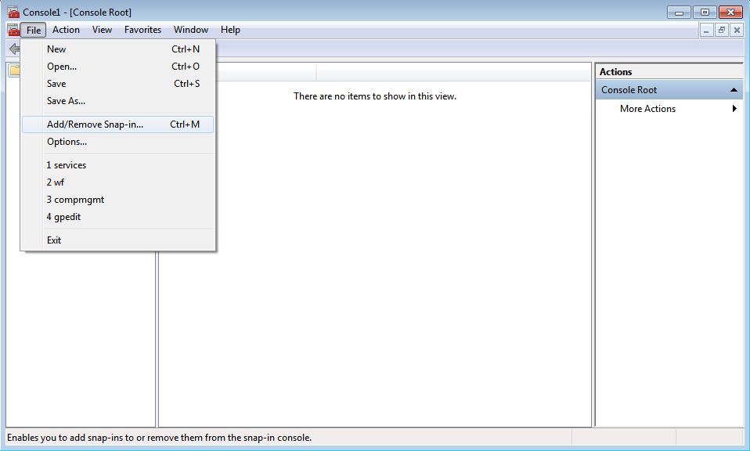

* In the “Available snap-ins” list box select certificate and click “add”, a new window will open choose ”My user account” radio button and click finish.

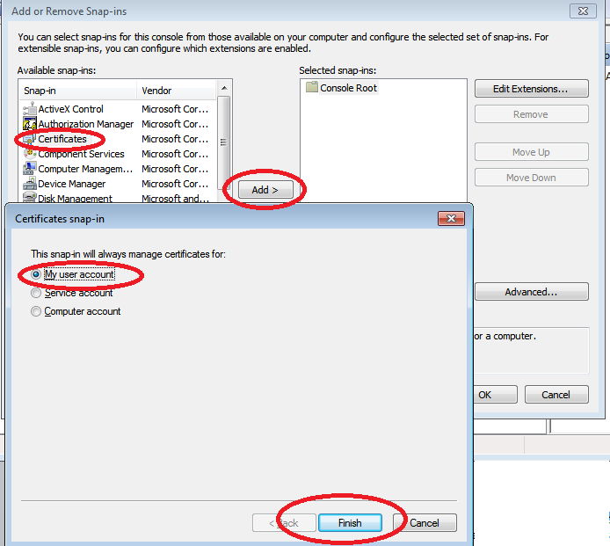

* Now, you can see the “certificates” inside the selected snap-ins box, and click “ok ” button.

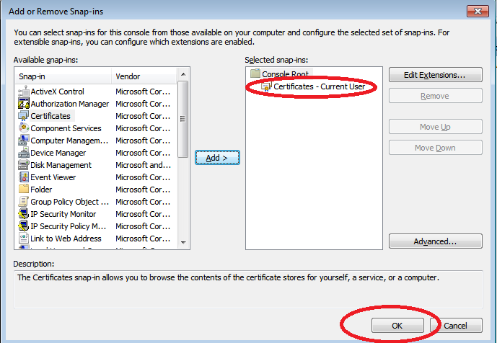

* Now under the Console root folder, open the Certificates and right click the “Trusted Root Certification Authorities”, select “All Task” and click “Import”.

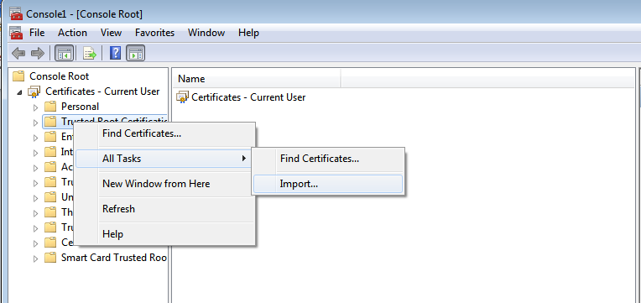

* The “Certificate Import Wizard” window will open, Click next and browse the “Kirby Glad” certificate, which can be found in the “ActionTRAK Connector_Publish” folder.

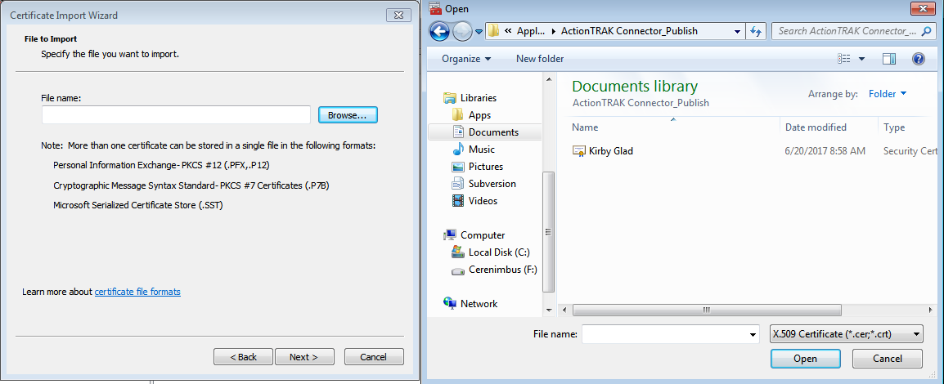

* Select the certificate, click next, and select the “Place all certificates in the following store” radio button.

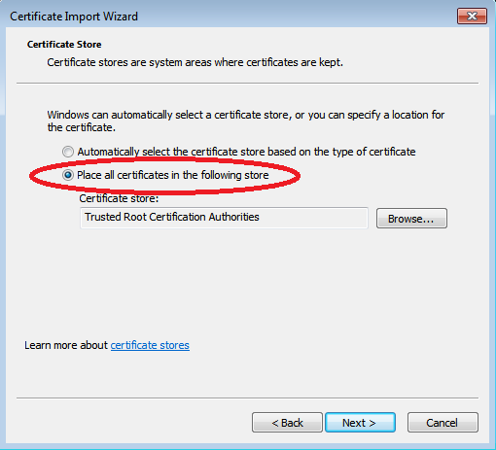

* Now, click the browse button, select the “Trusted Root Certification Authorities” folder and click “ok”.

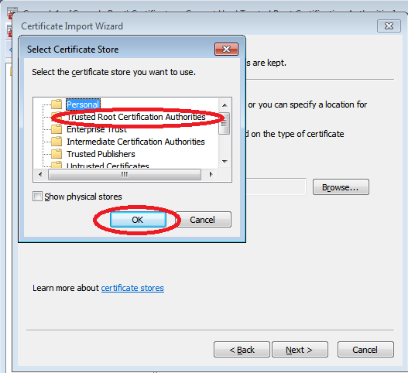

* Now, click next and you can see the details of the settings you’ve made. Then click finish button.

Lastly: Run the “ActionTrak Connector” and it will automatically integrate the PO and SO from actiontrak website into the QB desktop. (Note: this application will only process those PO and SO that has a modified date which is equal or later than the synchronized date in the synchronized csv file.)

Note: ActionTrak Credentials can be found in “ActionTrakCred” csv file.